(For Office Use Only) Campus name: _____________________________ Number: ___________________
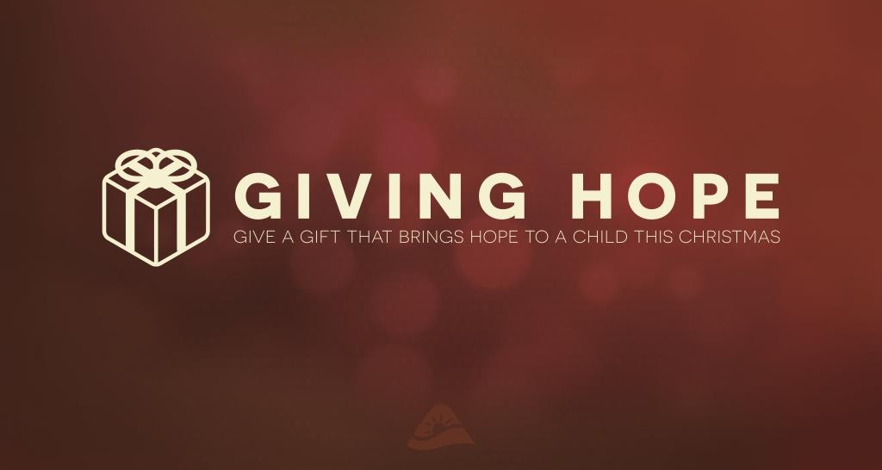

2016 INFORMATION FORM

Form must be submitted on original document. No copies will be accepted.
(All applications are not final until reviewed and approved.)

Parent’s Name: _____________________________________________________________________________________
(First) (Last)
Mailing Address: ___________________________________________________________________________________
(Street Name) (City) (State) (Zip Code)
Phone Numbers:
Home: _____________________________ Alternate: _______________________________
(Failure to provide working numbers or correct mailing addresses may result in delay in receiving gifts.)

(For children that you are the legal parent and/or guardian of)

Child’s Name: DOB: Age: Grade: School: (Circle one)
_________________________ ____________ _______ _________ ___________________________ Boy or Girl
_________________________ ____________ _______ _________ ___________________________ Boy or Girl
_________________________ ____________ _______ _________ ___________________________ Boy or Girl
_________________________ ____________ _______ _________ ___________________________ Boy or Girl
_________________________ ____________ _______ _________ ___________________________ Boy or Girl
_________________________ ____________ _______ _________ ___________________________ Boy or Girl
_________________________ ____________ _______ _________ ___________________________ Boy or Girl
_________________________ ____________ _______ _________ ___________________________ Boy or Girl
_________________________ ____________ _______ _________ ___________________________ Boy or Girl
_________________________ ____________ _______ _________ ___________________________ Boy or Girl

How did you get connected with Giving Hope?
__________________________________________________________________________________________________________________________________________________________________________________________________________________
_________________________________________________________________________________________________________

Forms Due: Nov. 6th

